**Lab15 – Understanding Local Redundant Storage (LRS) - Azure**

**Locally redundant storage (LRS): (Low-cost data redundancy)**

Locally redundant storage (LRS) provides at least 99.999999999% (11 nines) durability of objects over a given year. LRS provides this object durability by replicating your data to a storage scale unit. A datacenter, located in the region where you created your storage account, hosts the storage scale unit. A write request to an LRS storage account returns successfully only after the data is written to all replicas. Each replica resides in separate fault domains and update domains within a storage scale unit.

A storage scale unit is a collection of racks of storage nodes. A fault domain (FD) is a group of nodes that represent a physical unit of failure. Think of a fault domain as nodes belonging to the same physical rack. An upgrade domain (UD) is a group of nodes that are upgraded together during the process of a service upgrade (rollout). The replicas are spread across UDs and FDs within one storage scale unit. This architecture ensures your data is available if a hardware failure affects a single rack or when nodes are upgraded during a service upgrade.

LRS is the lowest-cost replication option and offers the least durability compared to other options. If a datacenter-level disaster (for example, fire or flooding) occurs, all replicas may be lost or unrecoverable. To mitigate this risk, Microsoft recommends using either zone-redundant storage (ZRS) or geo-redundant storage (GRS).

* If your application stores data that can be easily reconstructed if data loss occurs, you may opt for LRS.
* Some applications are restricted to replicating data only within a country due to data governance requirements. In some cases, the paired regions across which the data is replicated for GRS accounts may be in another country.

**Topology**

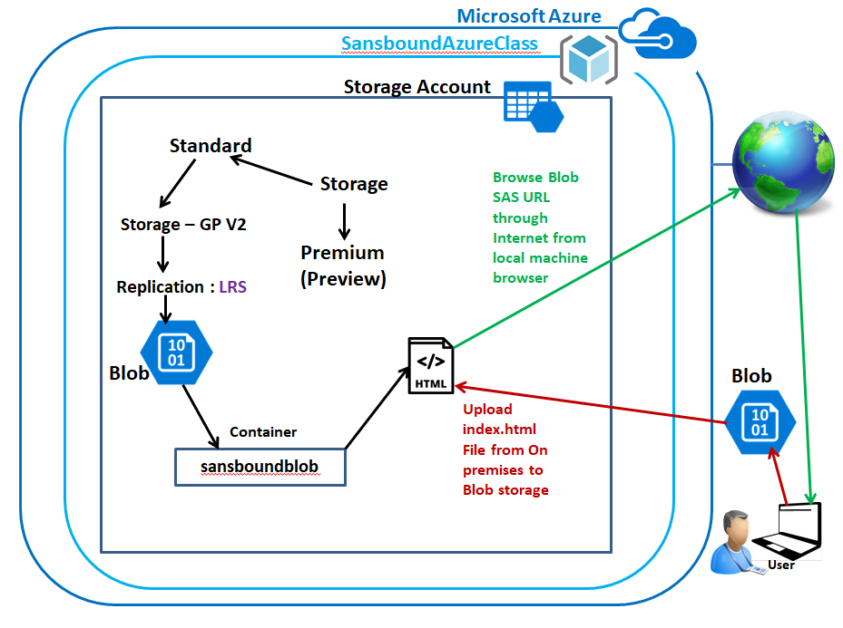

**Locally Redundant Storage (Back-End):**

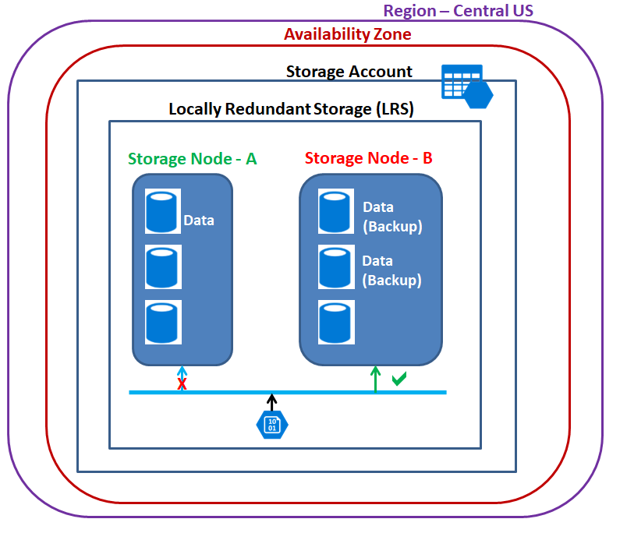

In Azure portal, click **“Resource groups”**.

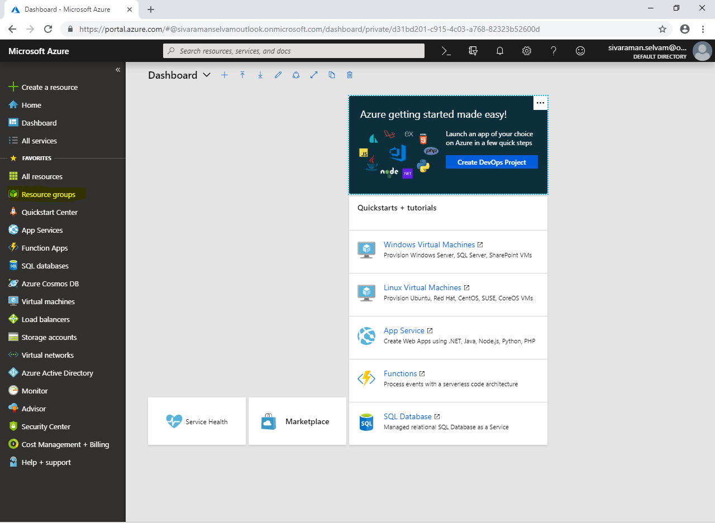

Click **“Add”**.

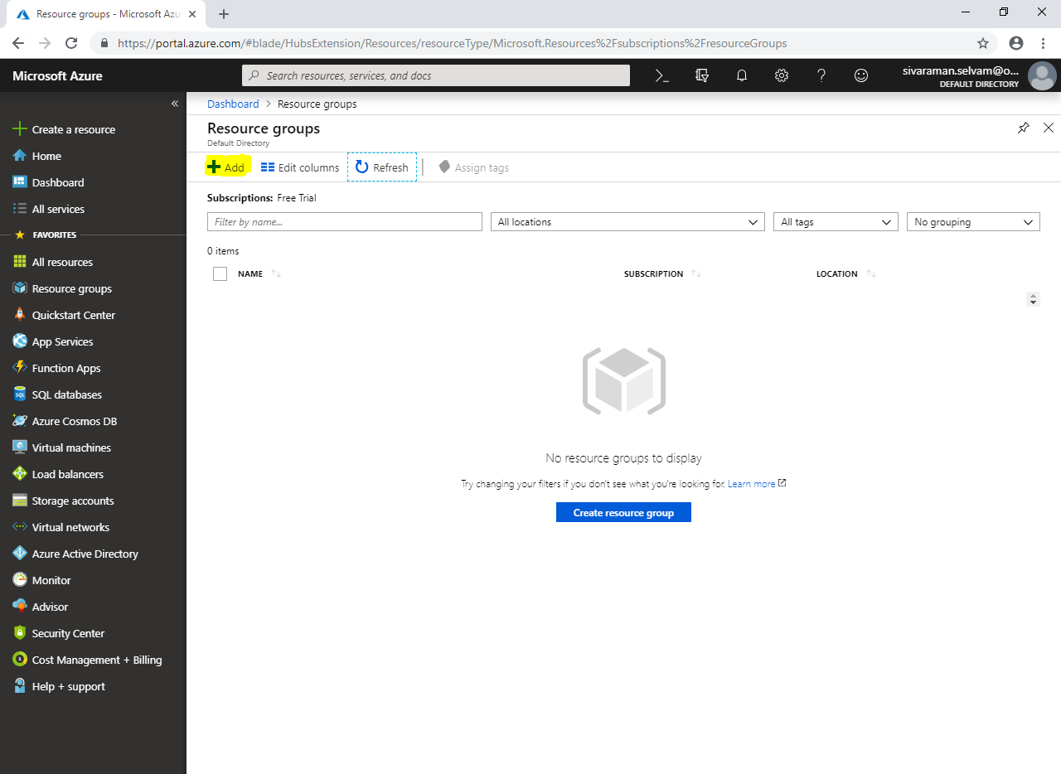

While create **“Resource group”**

Type **“Resource group name”** as **“SansboundAzureClass”**.

Select **“Subscription”** as **“Free Trial”**.

Select **“Resource group location”** as **“Central US”**.

Click **“Create”**.

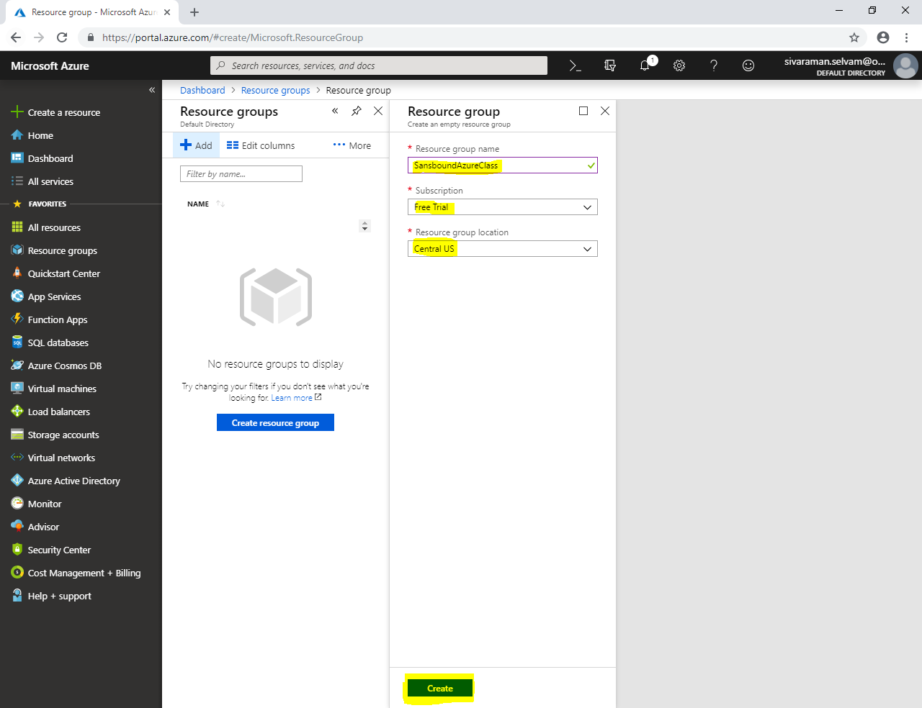

Click **“Storage accounts”** in left side panel.

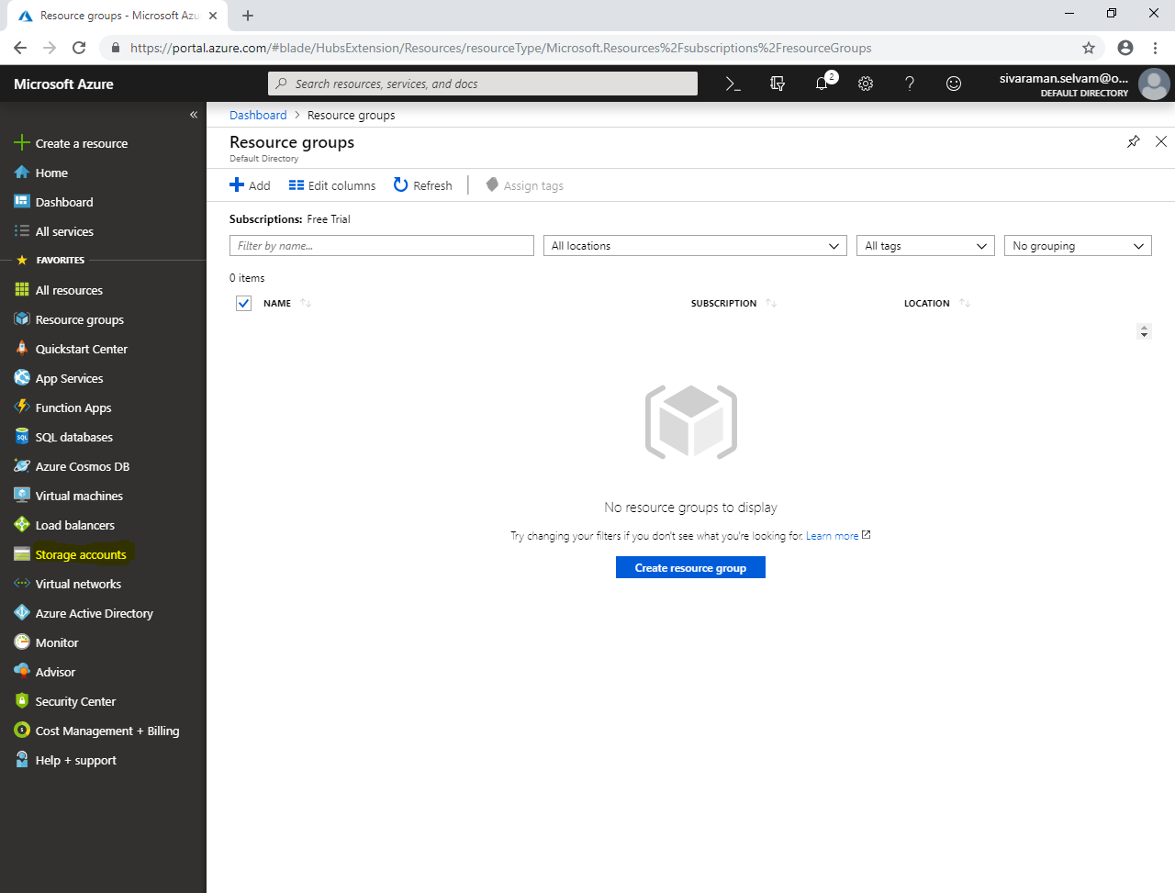

In **“Storage accounts”**.

Click **“Add”**.

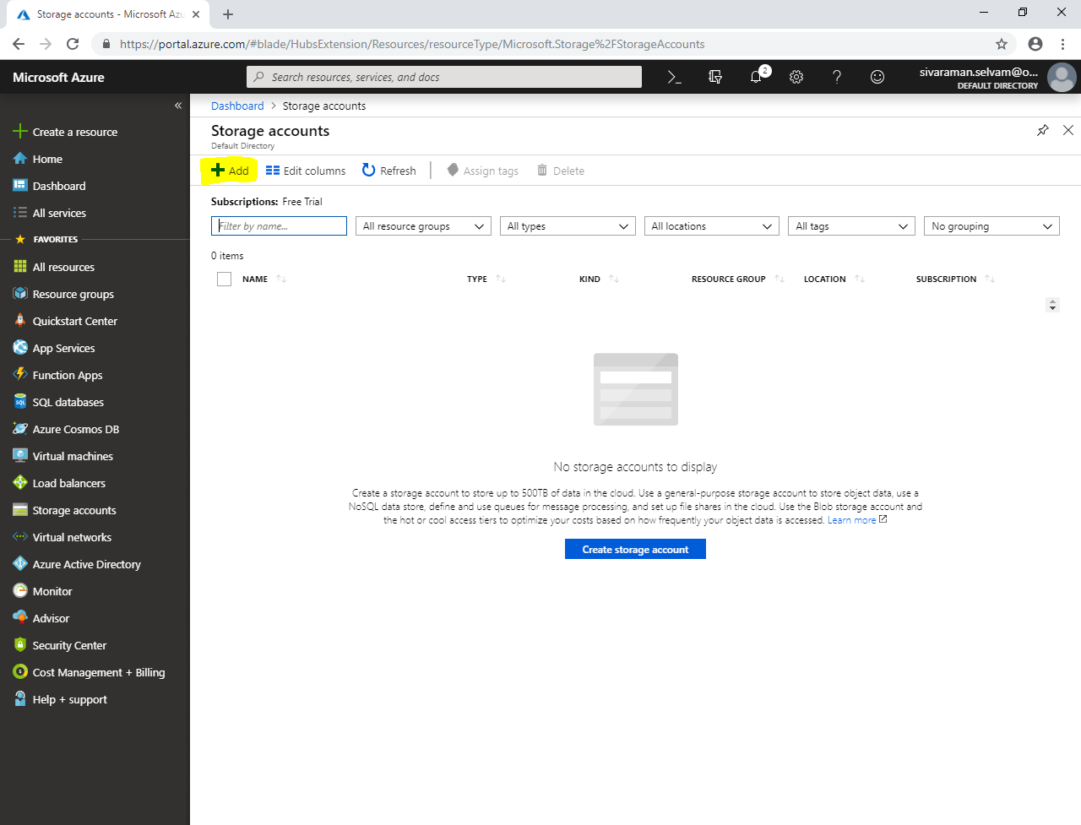

Select **“Subscription”** as **“Free Trial”**.

Select **“Resource group”** as **”SansboundAzureClass”**.

Type **“Storage account name”** as **“sansboundlrs”.**

Select **“Location”** as **“Central US”**.

In **“Performance”** click **”Standard”**.

Select **“Account kind”** as **“Storage (general purpose v2)”**.

Select **“Replication”** as **“Locally-redundant-storage (LRS)”**.

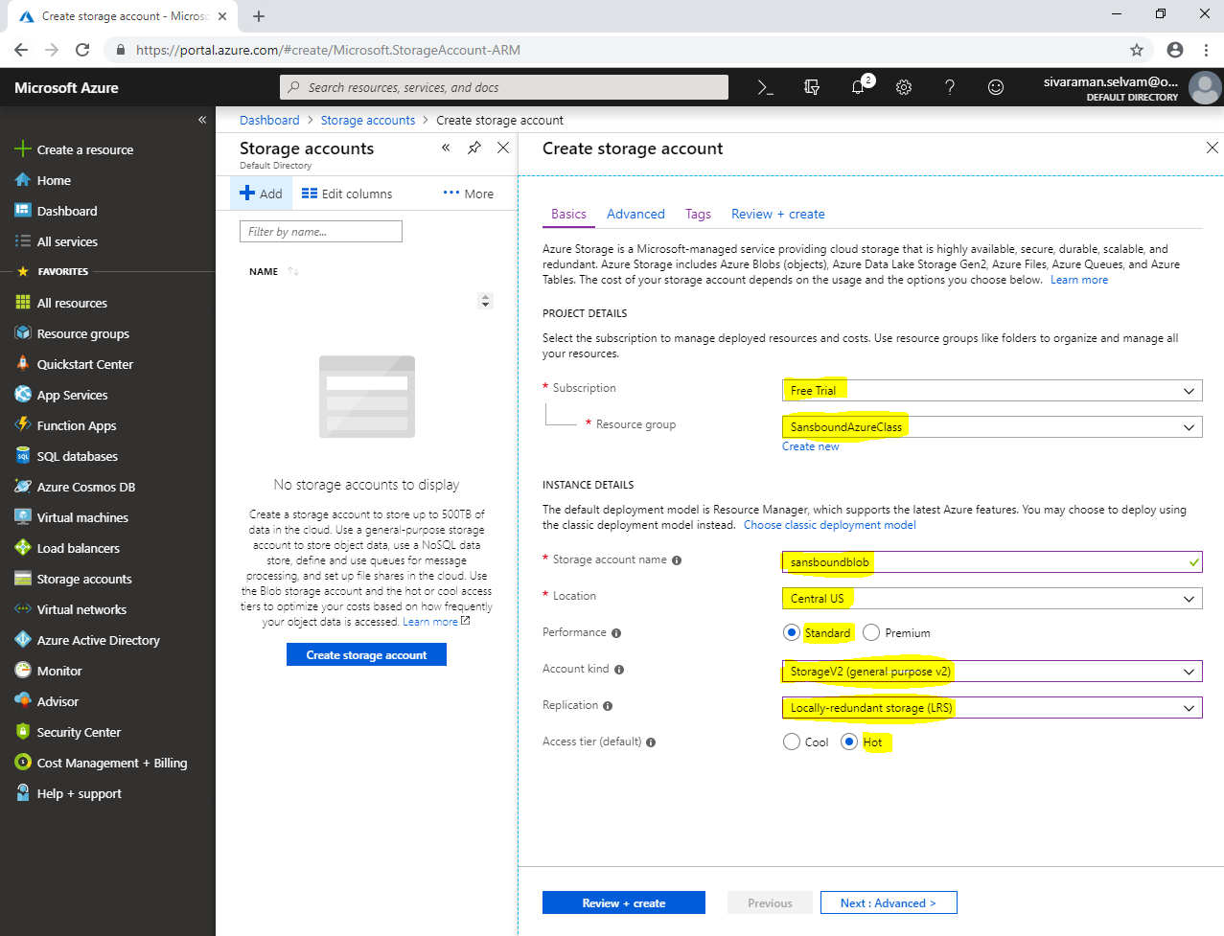

Click **“Next : Advanced >”**.

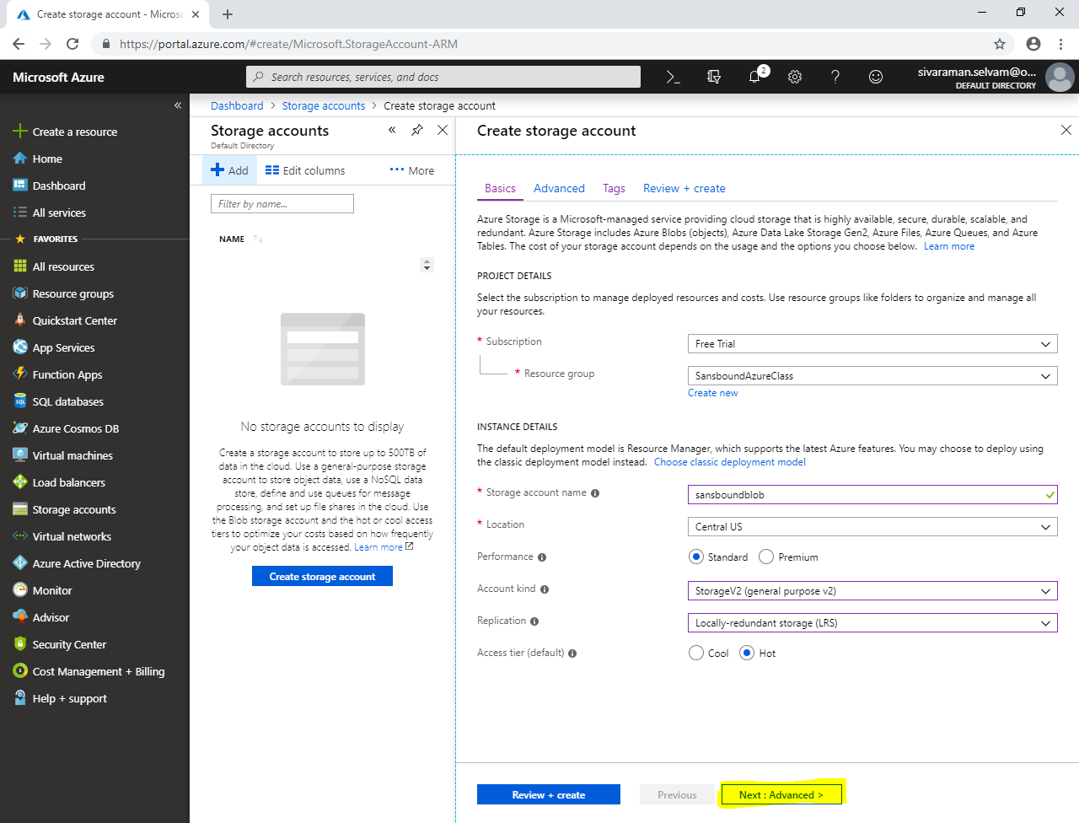

In **“Advanced”**,

Click **“Next : Tags >”** .

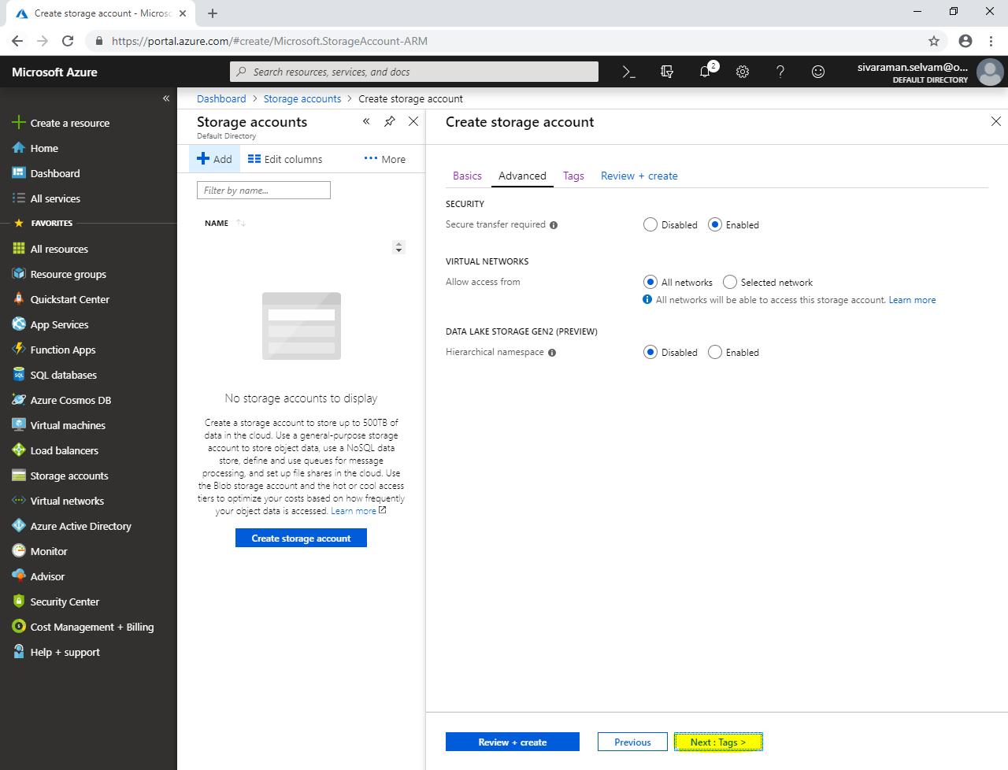

In **“Tags”**,

Type **“KEY”** as **“Name”** and **“VALUE”** as **“Sansbound-LRS”**.

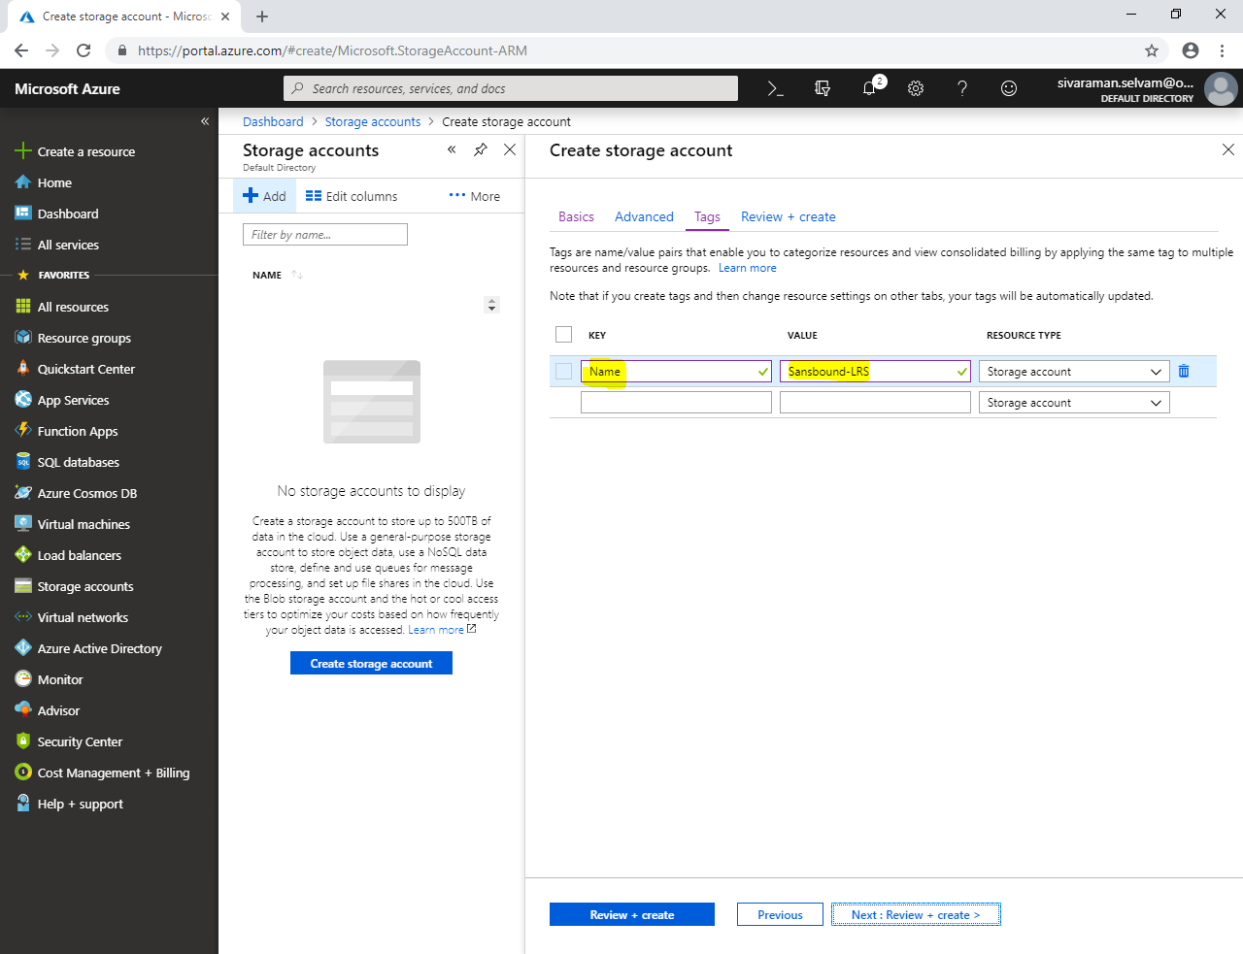

Click **“Next : Review + create”.**

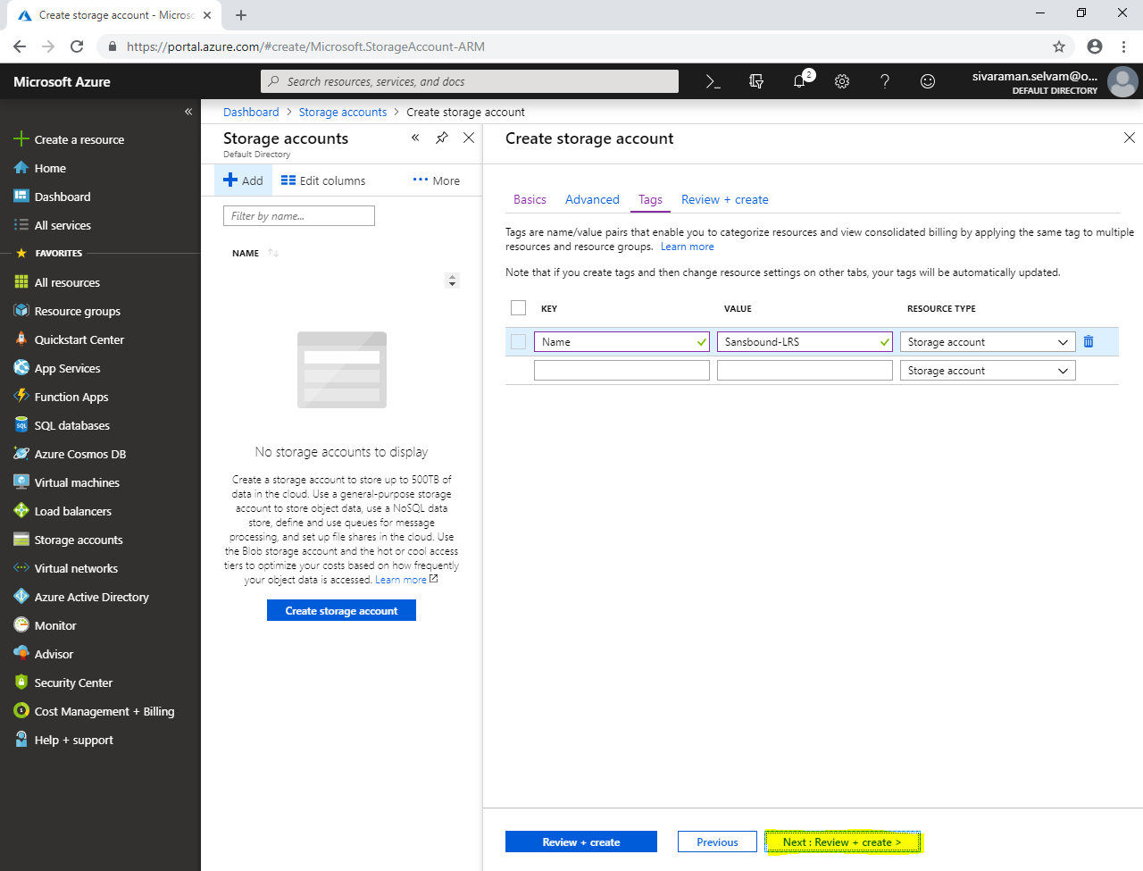

Click **“Create”**.

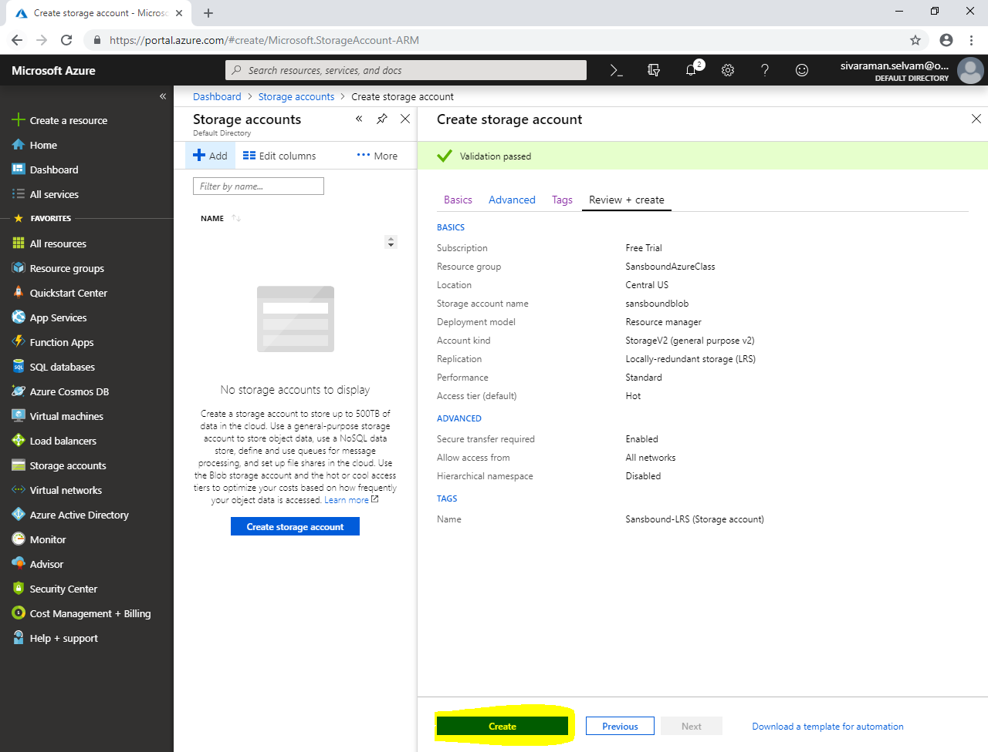

Click **“Go to resource”.**

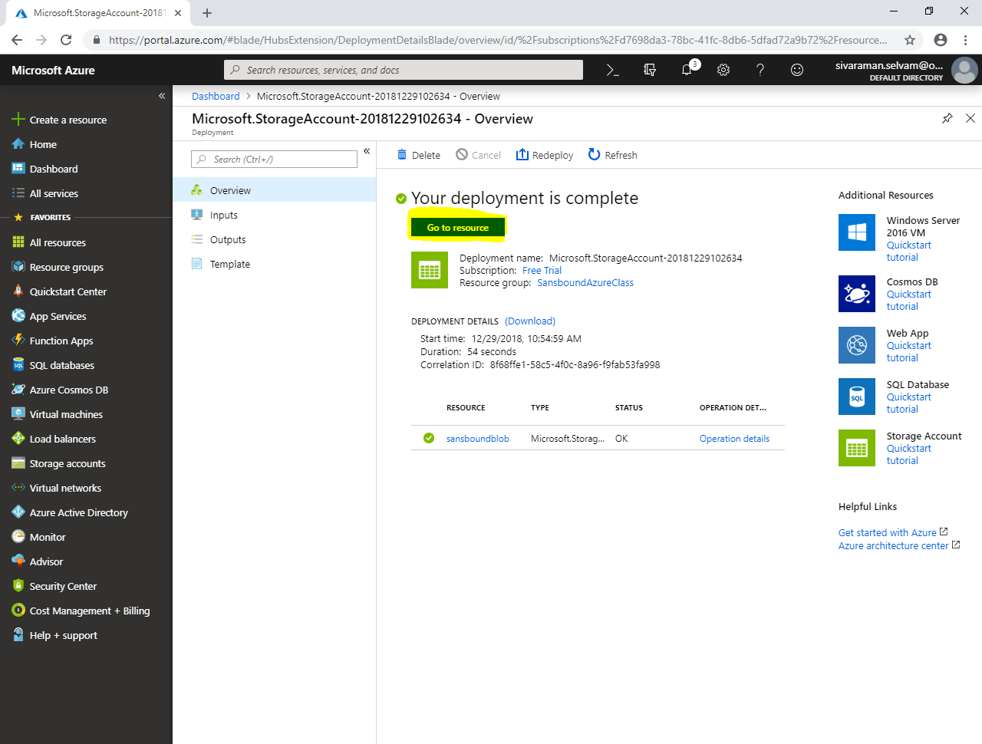

In **“sansboundblob”**.

Click **“Blobs”**.

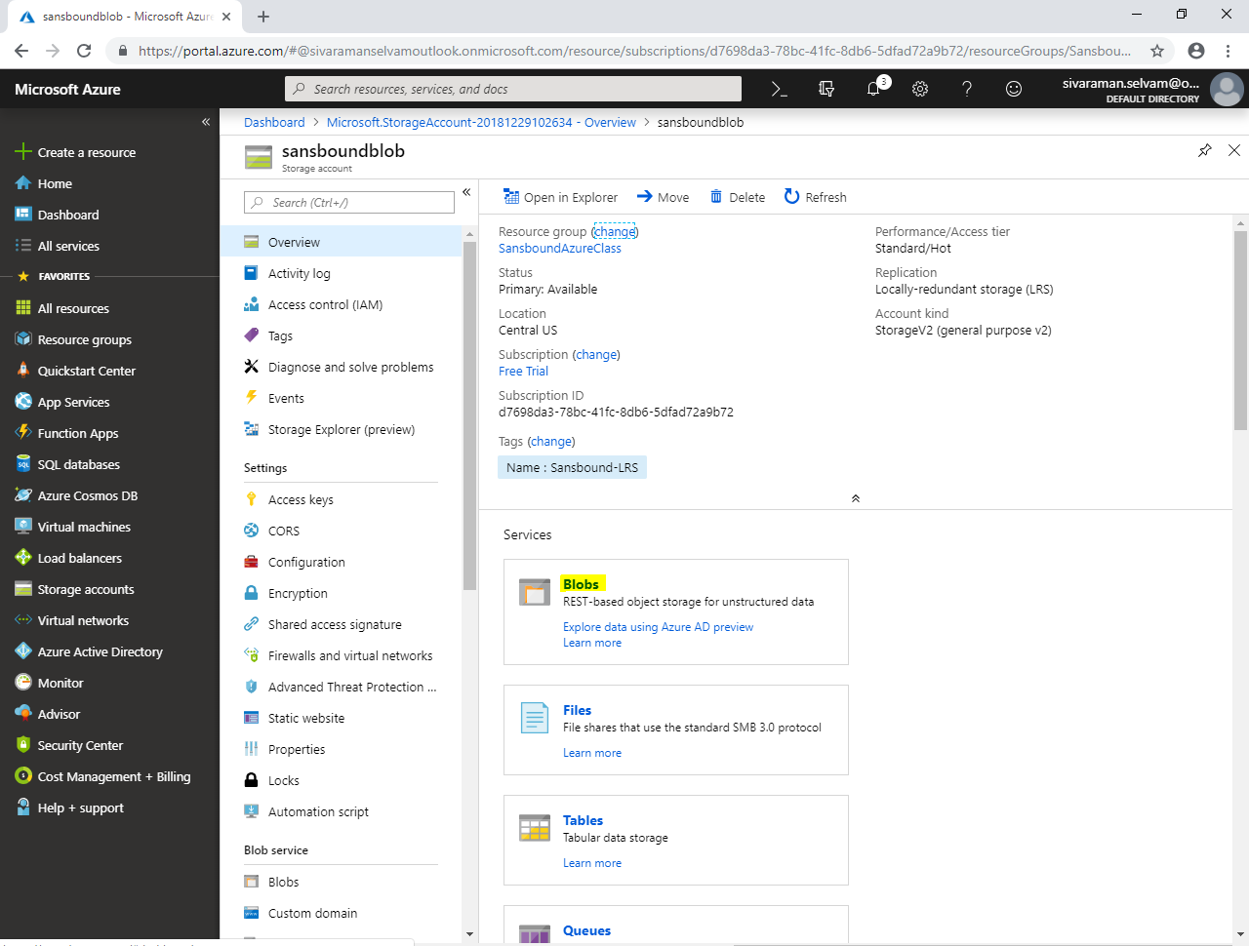

In **“Blobs”**.

Click **“Container”** to create container.

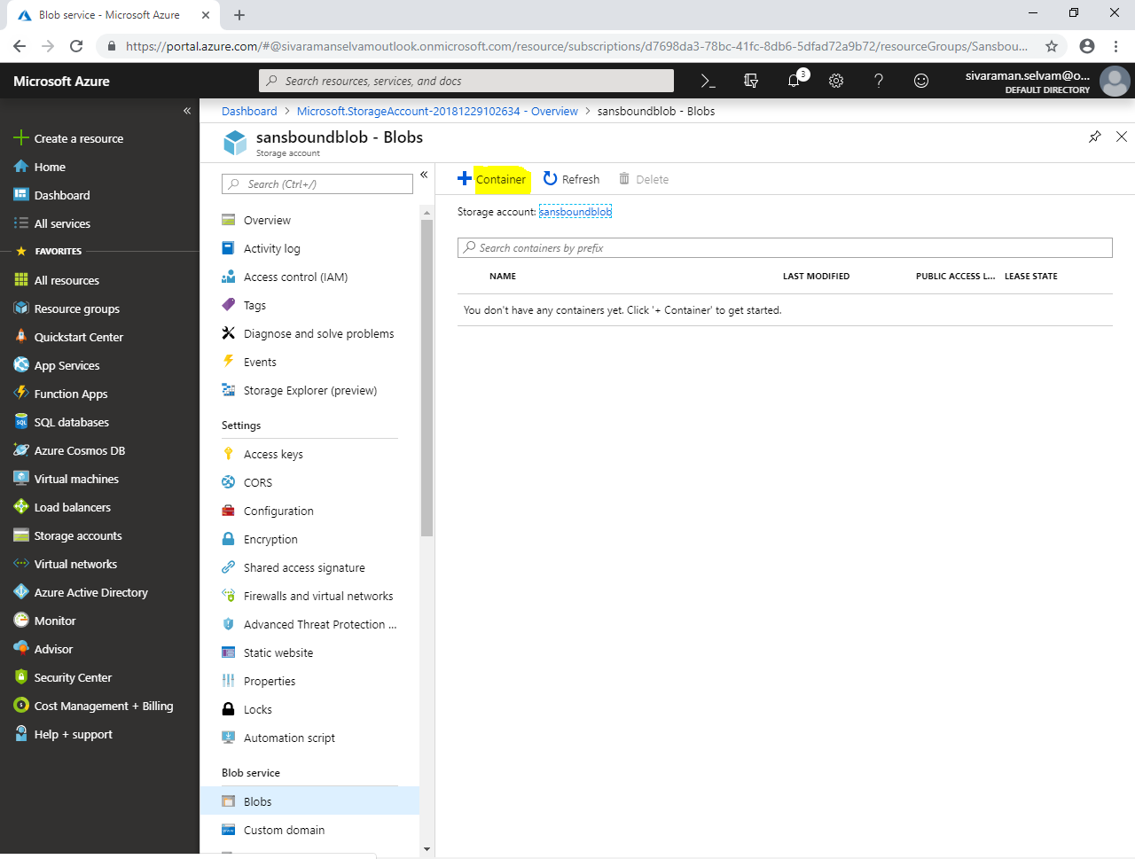

While create new container,

In **“Name”** type name as **“sansboundblob”**.

In **“Public access level”** select as **“Blob”**.

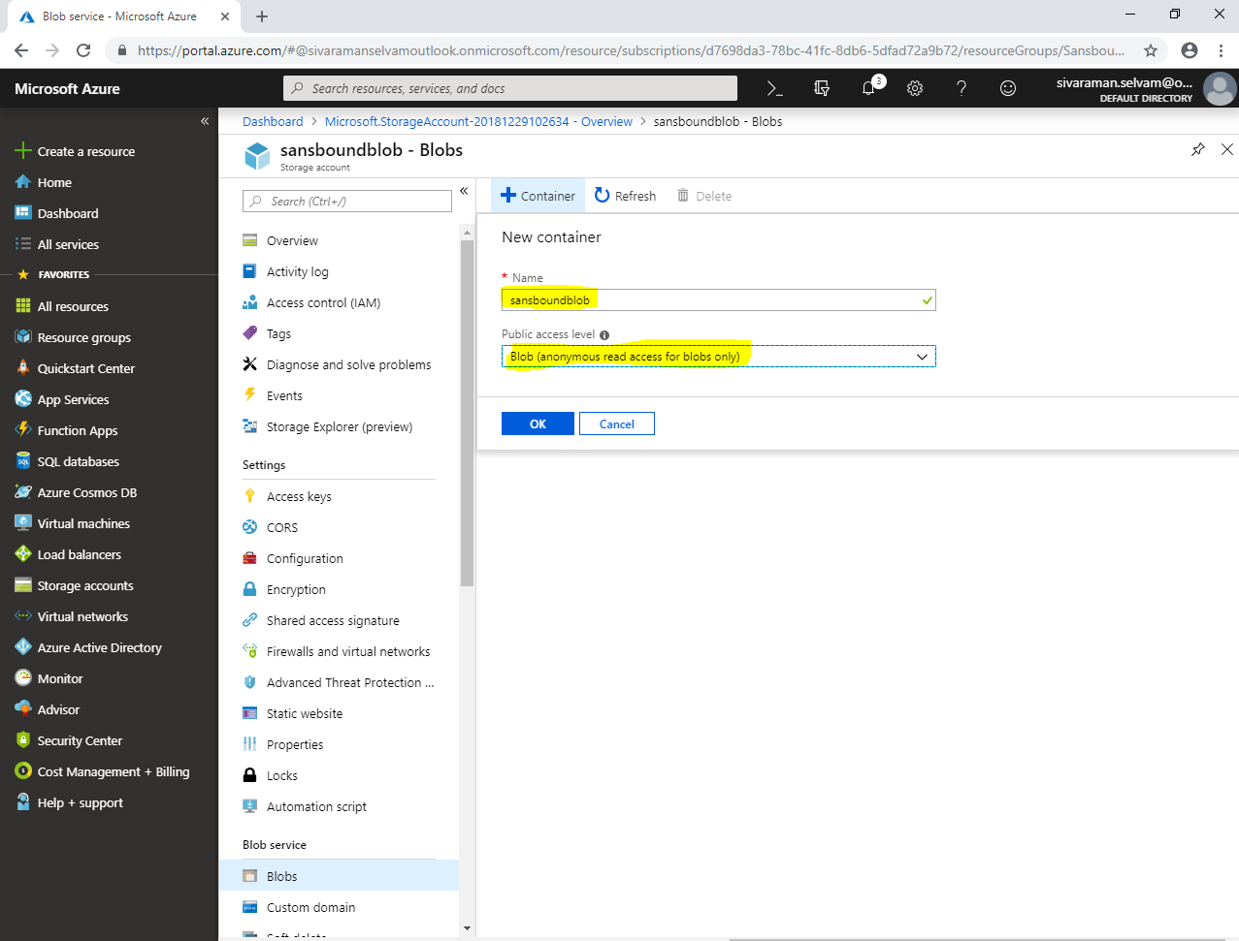

Click **“Ok”.**

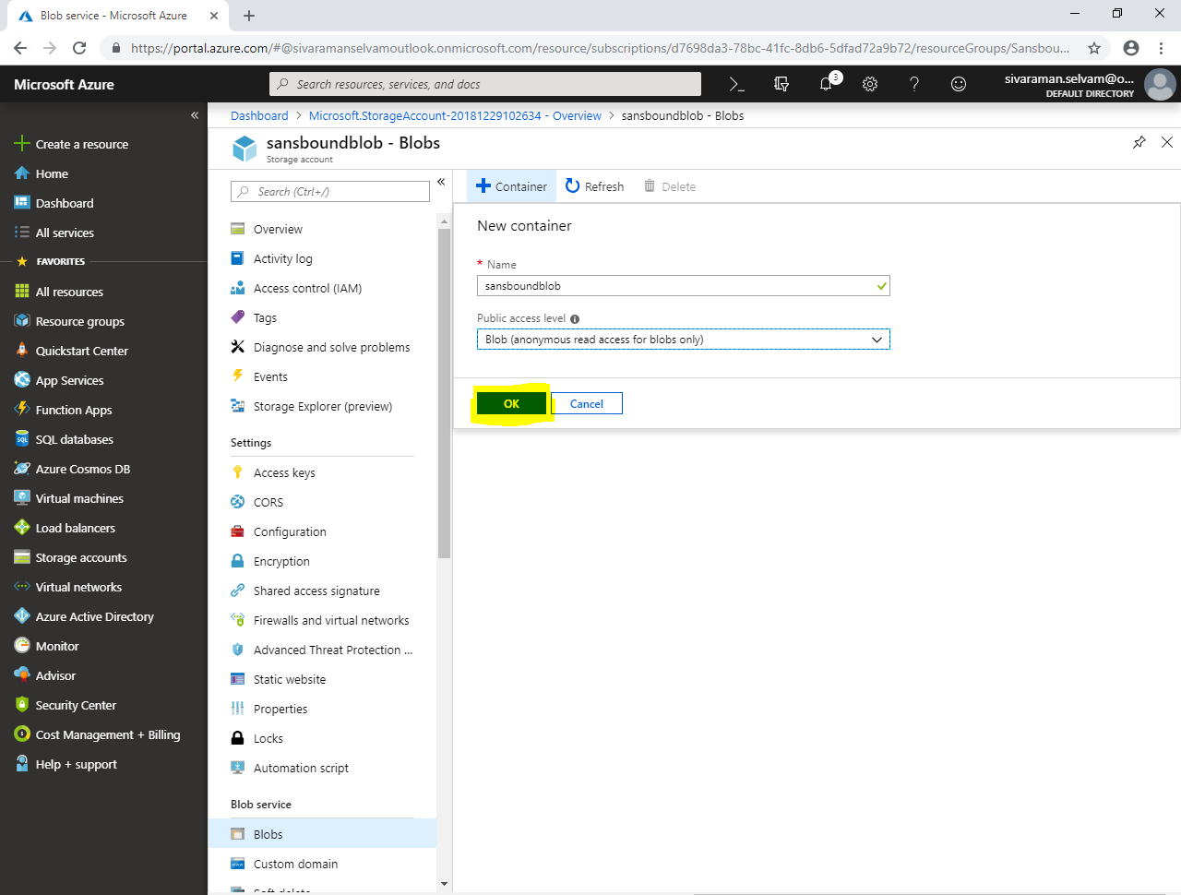

Click container named **“sansboundblob”**.

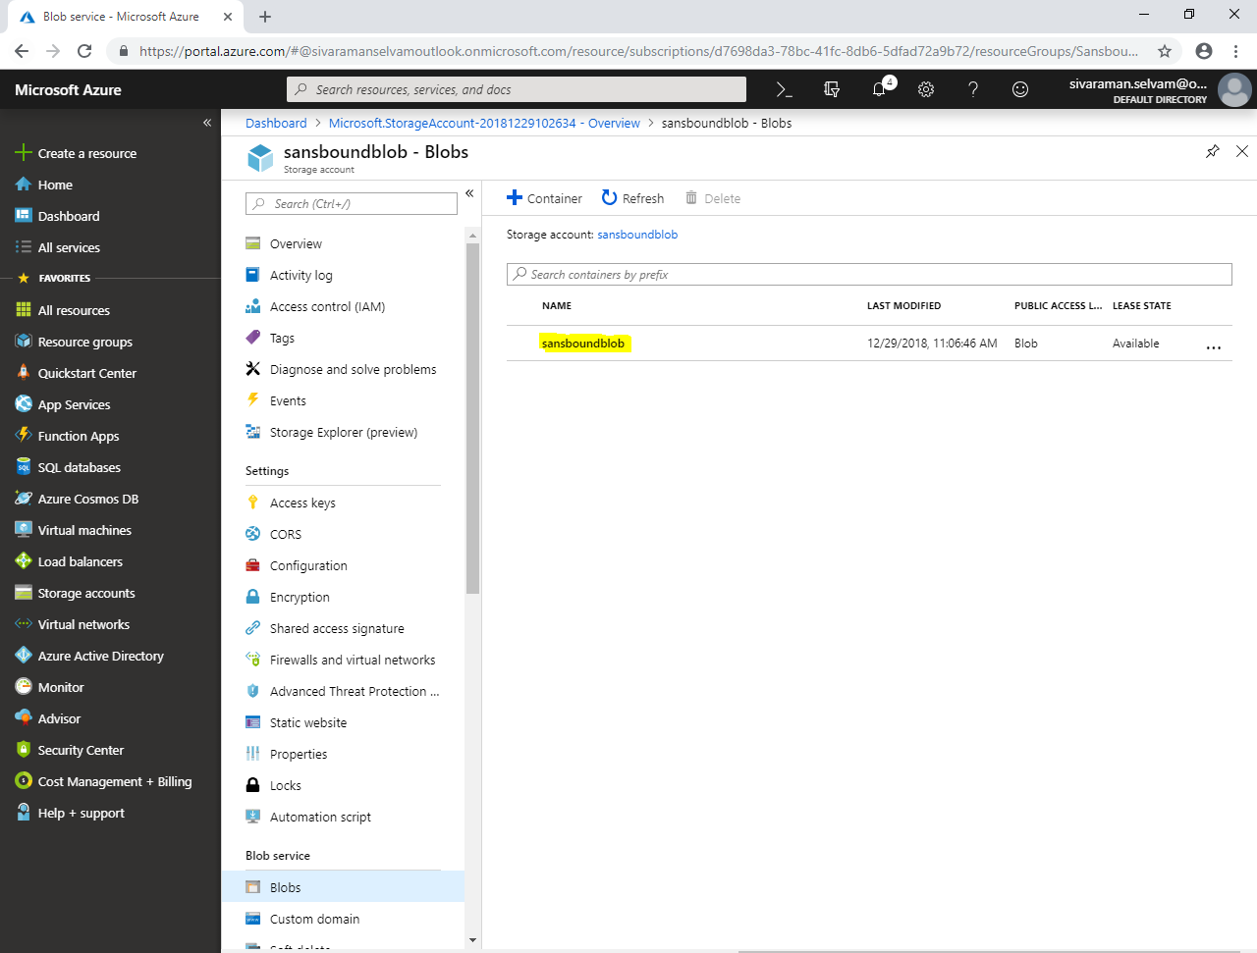

Click **“Upload”**.

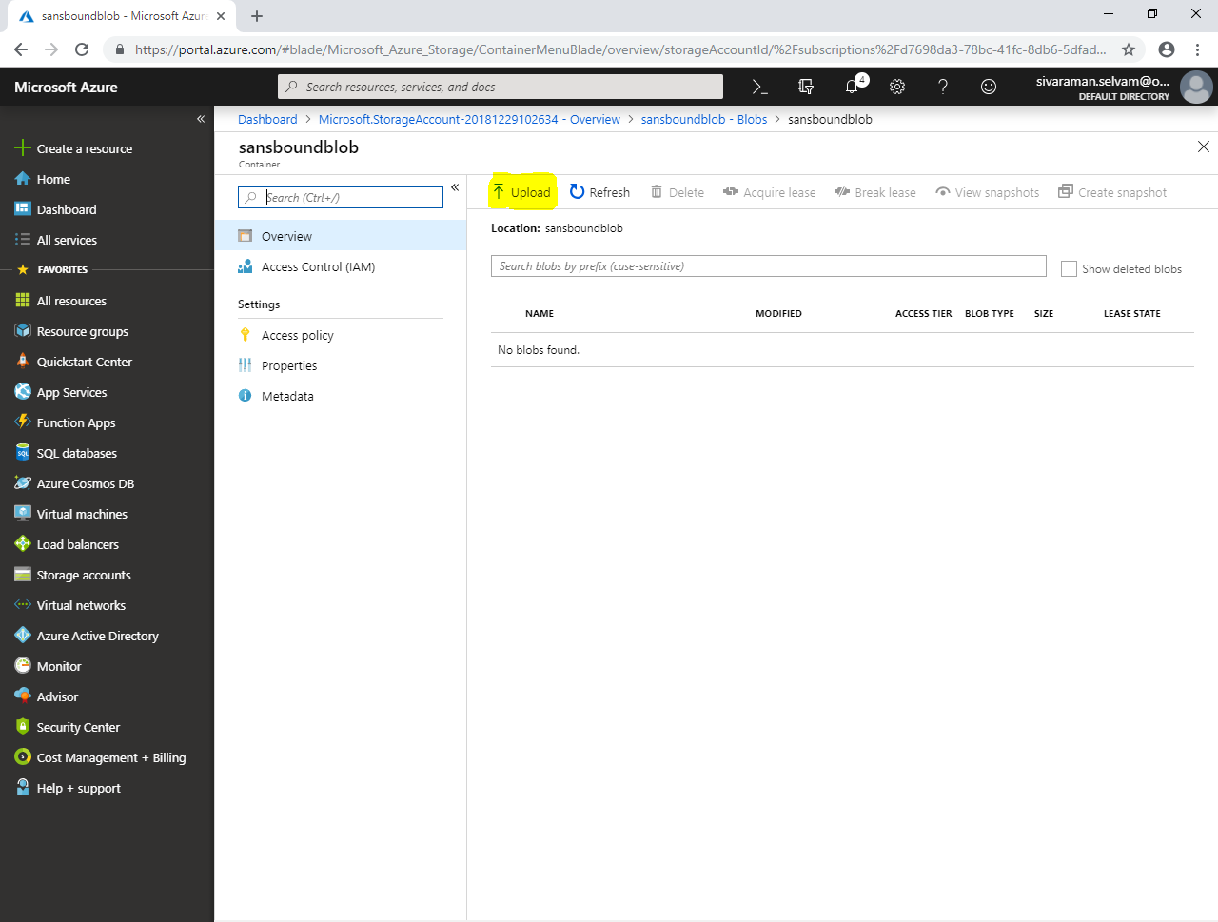

In **“Upload blob”**

Click **“Icon”**.

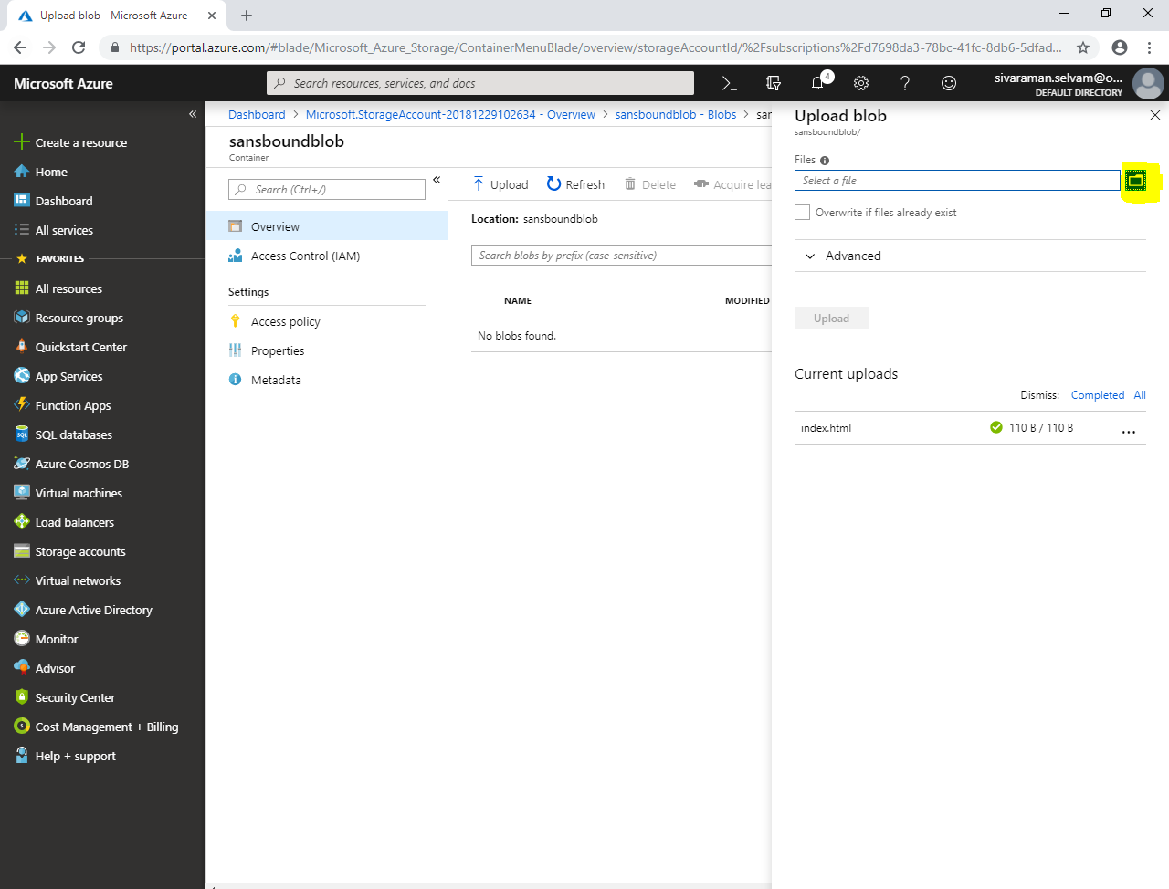

Locate the path of index.html file where you have stored and select **“index.html”** file.

Click **“Open”**.

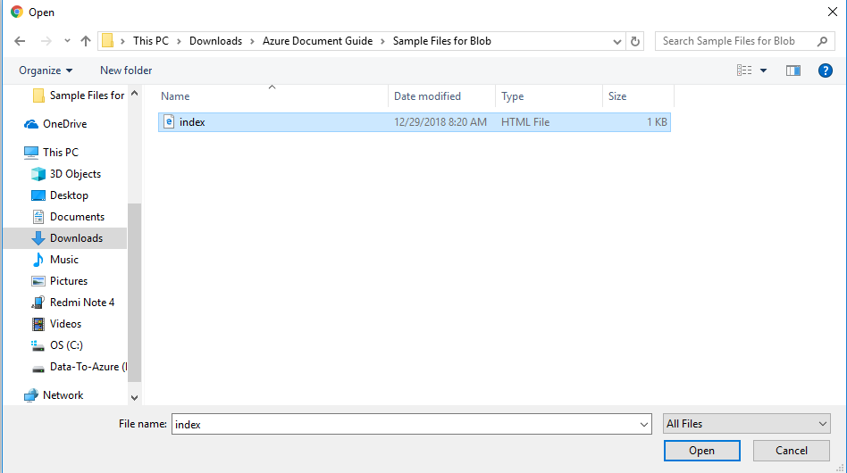

Click **“Upload”**.

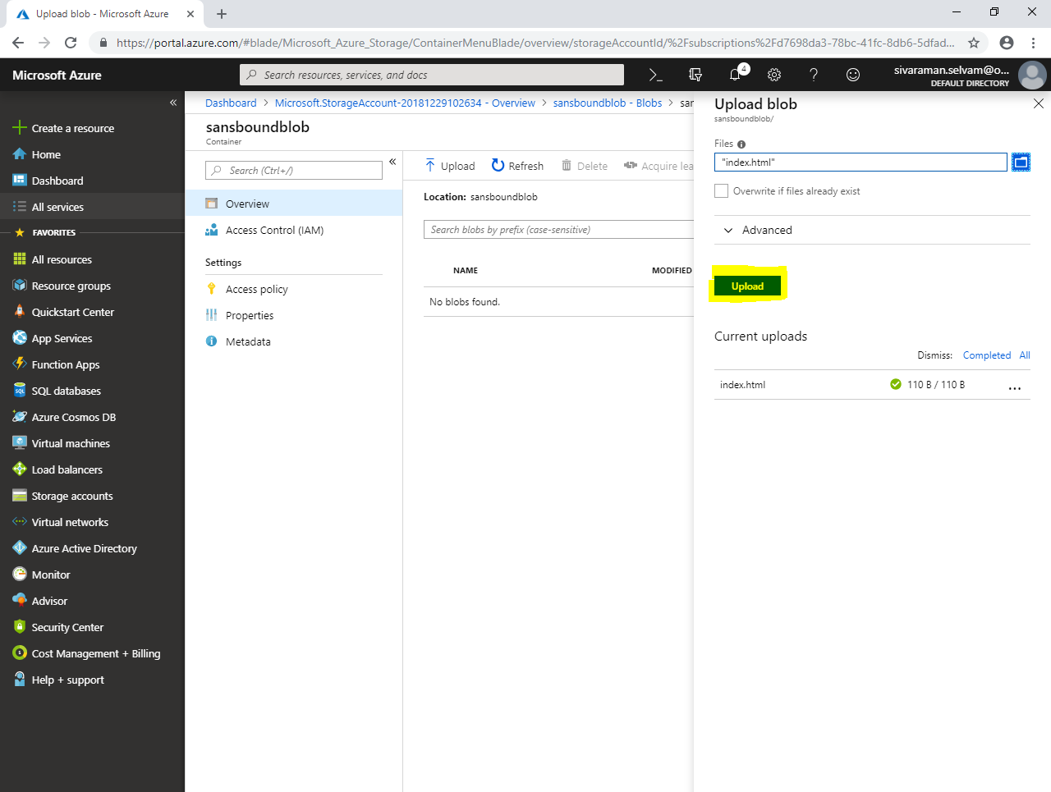

Click **“index.html”**.

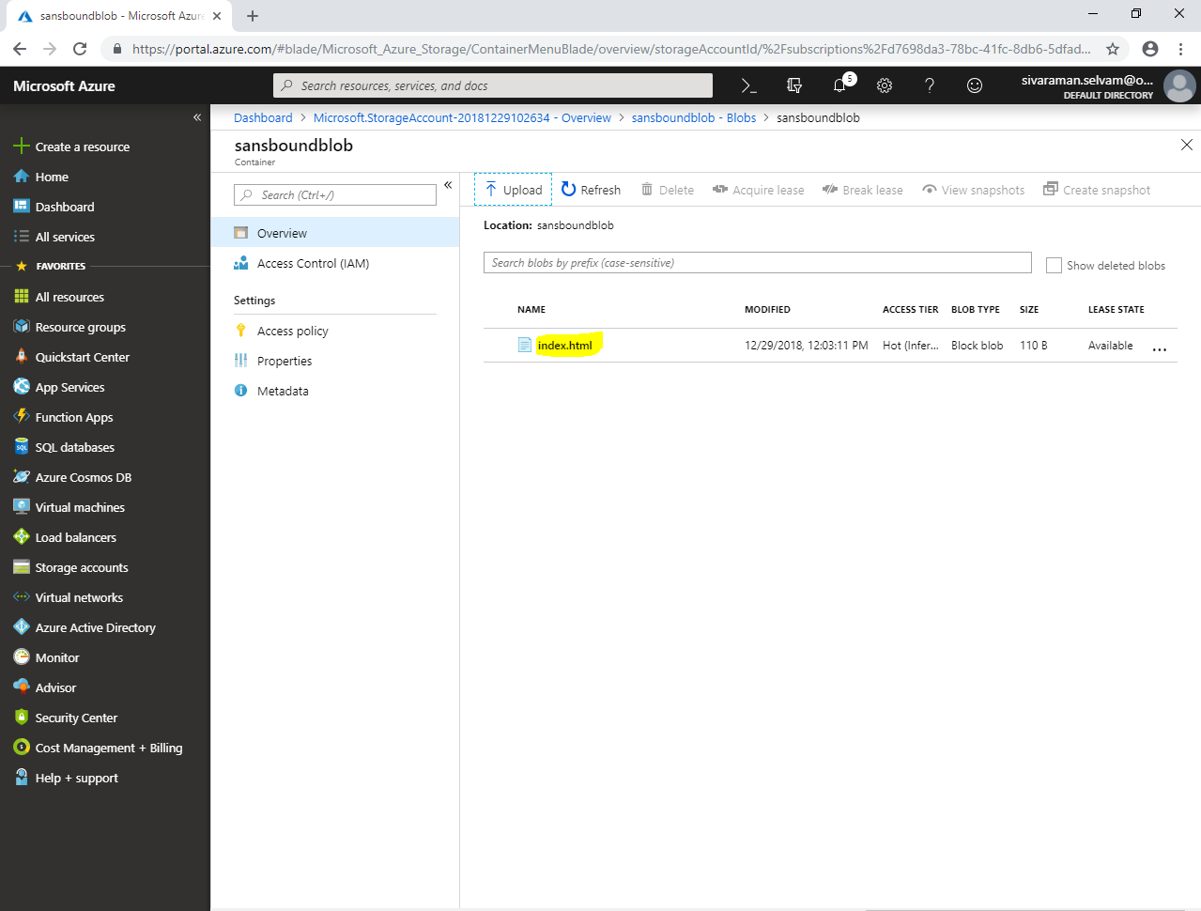

Click **“Generate SAS”**.

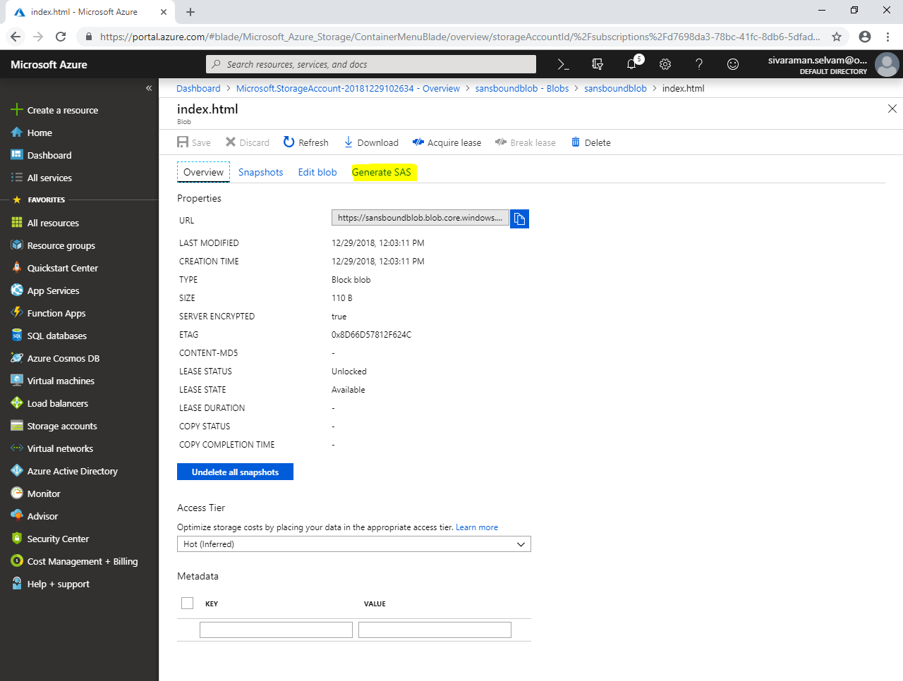

Click **“Generate blob SAS token and URL”**.

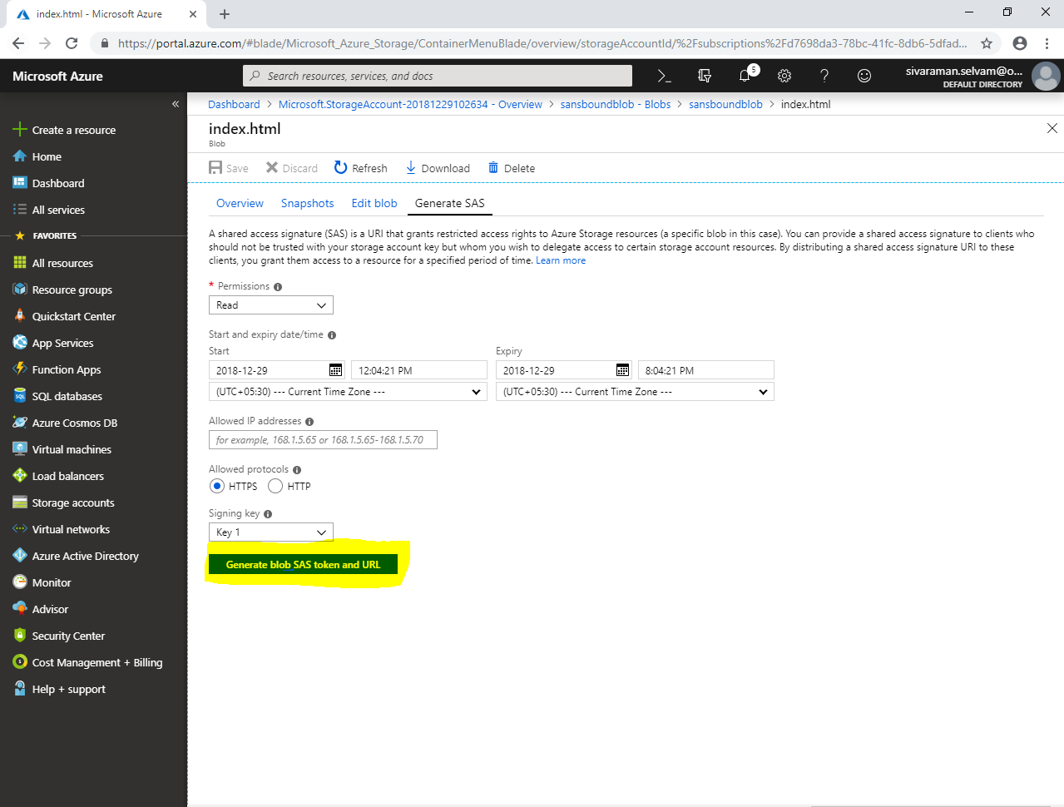

In **“Blob SAS URL”**

Click **“Icon”** to copy Blob SAS URL path.

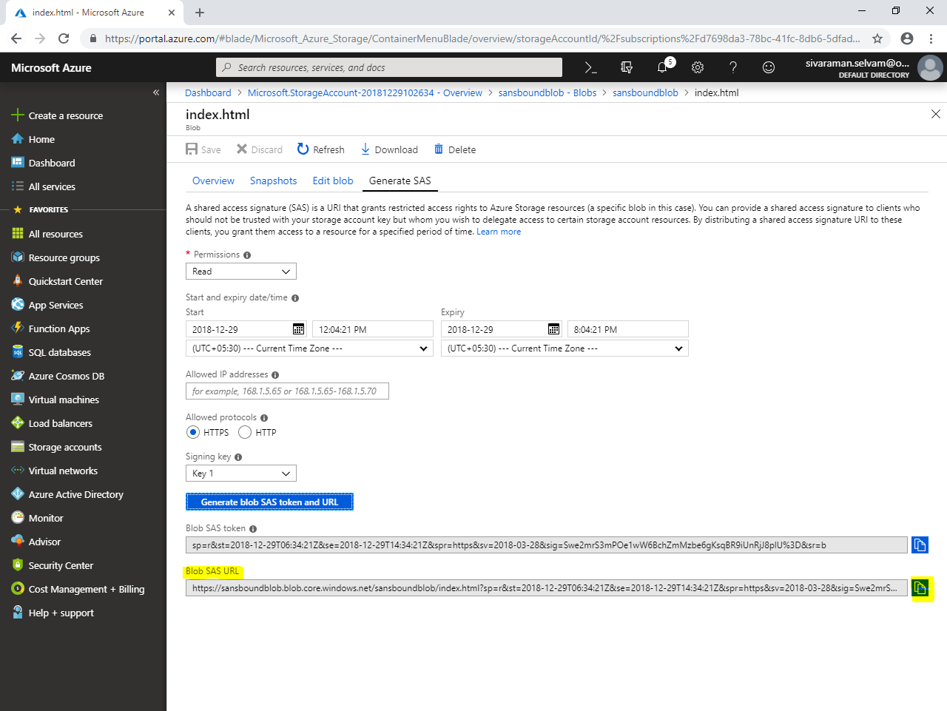

Paste “Blob URL” in browser and press **“Enter”**

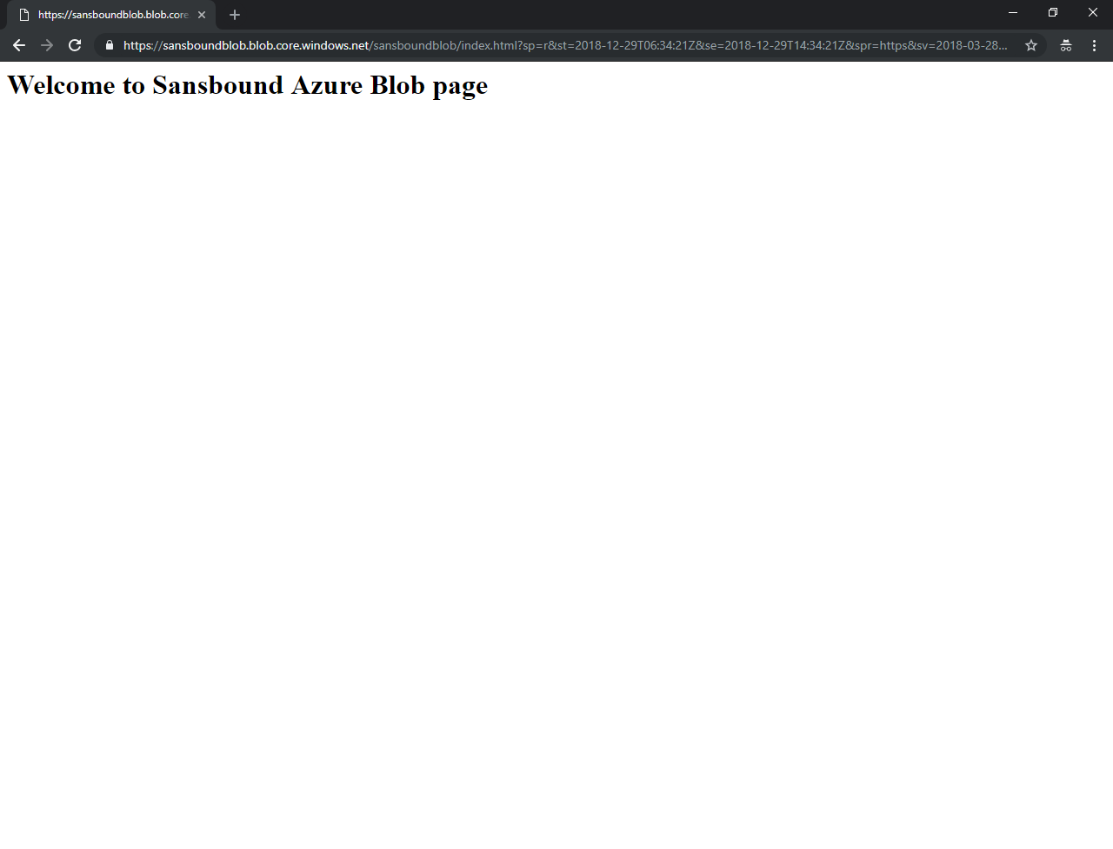

Note: Your data has been stored in same region in same availability zone in different storage nodes. If primary node failed, then you can able to access data from Secondary node.